**CTEC 3350  
Web Communication Design and Development 2**

**Flexbox – flex-flow: \***

Screenshot 1

Paste a copy of your screenshot including your Student Name and Student ID (here)

Paste the style declaration you used to make your screenshot happen.

display:   
flex-flow:

Screenshot 2

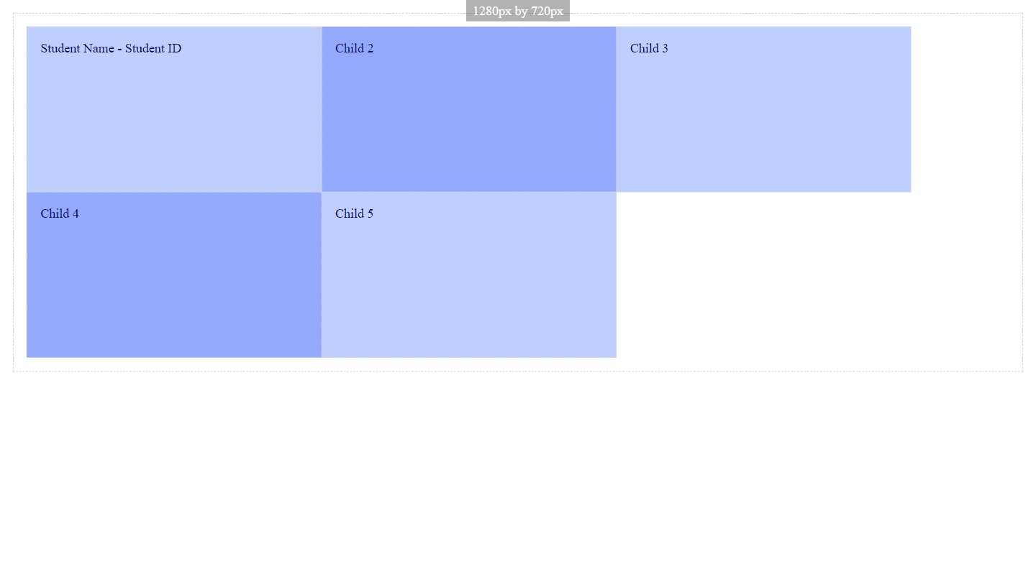

Paste a copy of your screenshot including your Student Name and Student ID (here)

Paste the style declaration you used to make your screenshot happen.

display:   
flex-flow:

Screenshot 3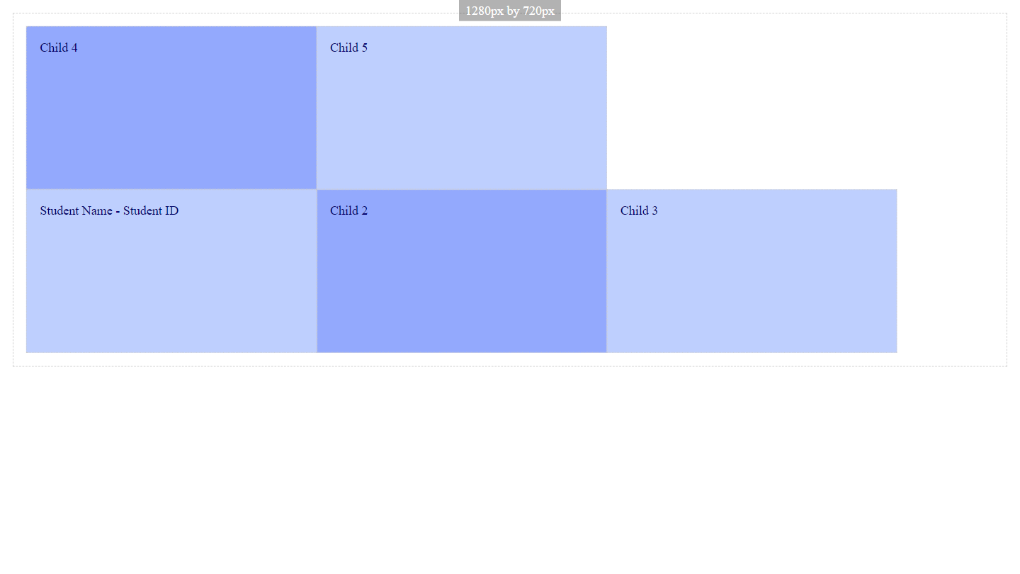

Paste a copy of your screenshot including your Student Name and Student ID (here)

Paste the style declaration you used to make your screenshot happen.

display:   
flex-flow:

Screenshot 4

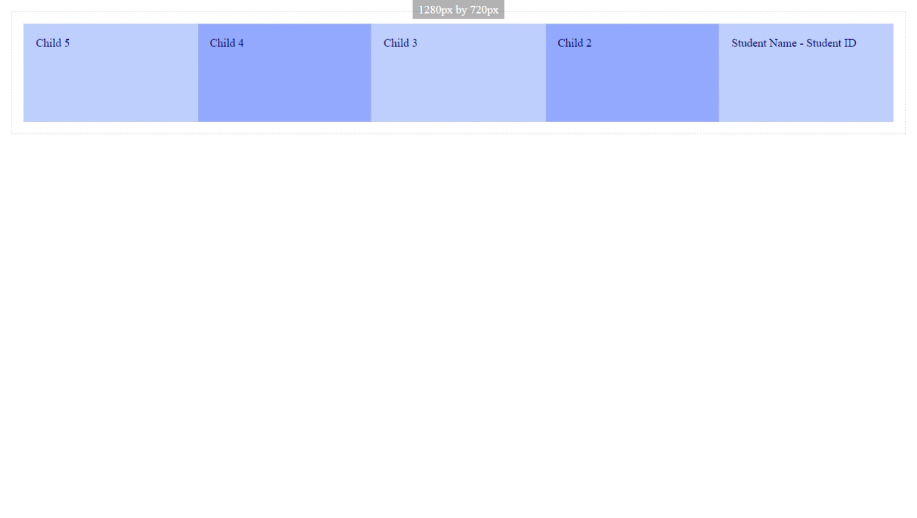

Paste a copy of your screenshot including your Student Name and Student ID (here)

Paste the style declaration you used to make your screenshot happen.

display:   
flex-flow:

Screenshot 5

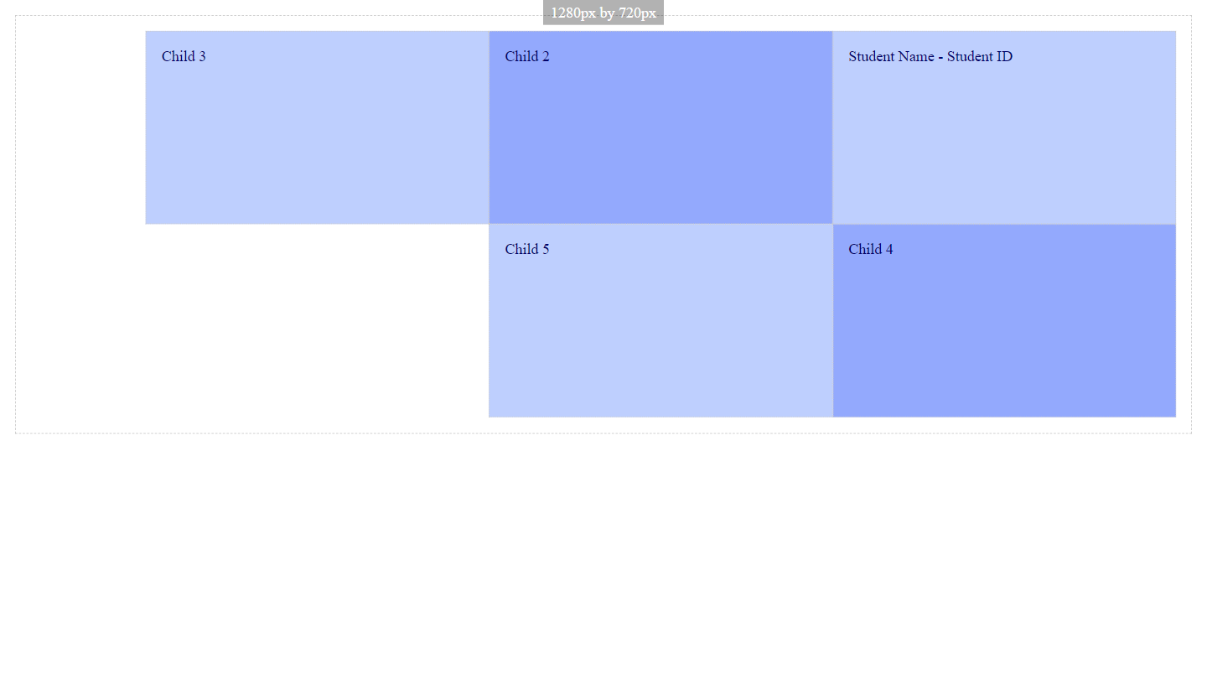

Paste a copy of your screenshot including your Student Name and Student ID (here)

Paste the style declaration you used to make your screenshot happen.

display:   
flex-flow:

Screenshot 6

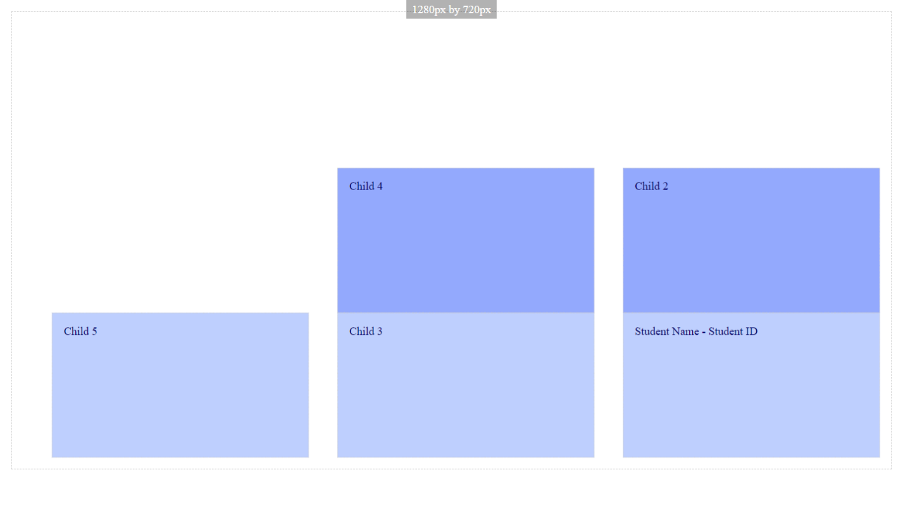

Paste a copy of your screenshot including your Student Name and Student ID (here)

Paste the style declaration you used to make your screenshot happen.

display:   
flex-flow:

Screenshot 7

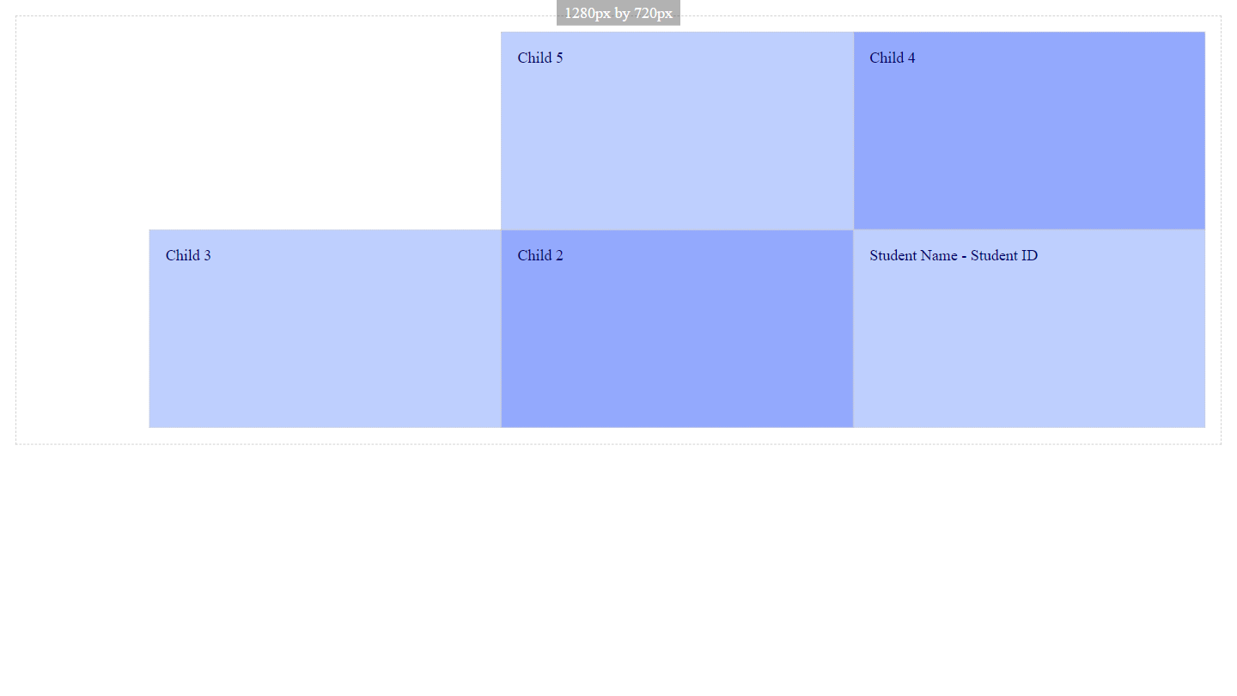

Paste a copy of your screenshot including your Student Name and Student ID (here)

Paste the style declaration you used to make your screenshot happen.

display:   
flex-flow:

Screenshot 8

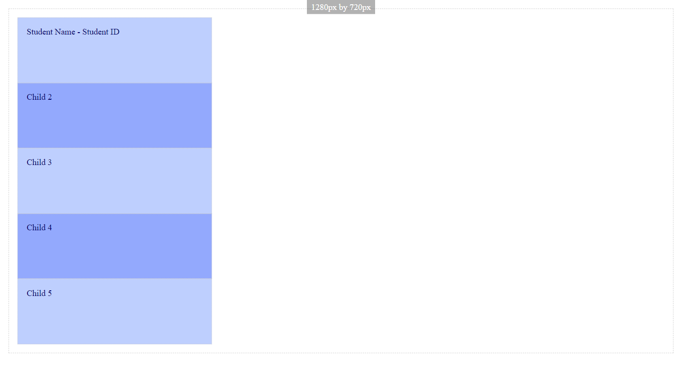

Paste a copy of your screenshot including your Student Name and Student ID (here)

Paste the style declaration you used to make your screenshot happen.

display:   
flex-flow:

Screenshot 9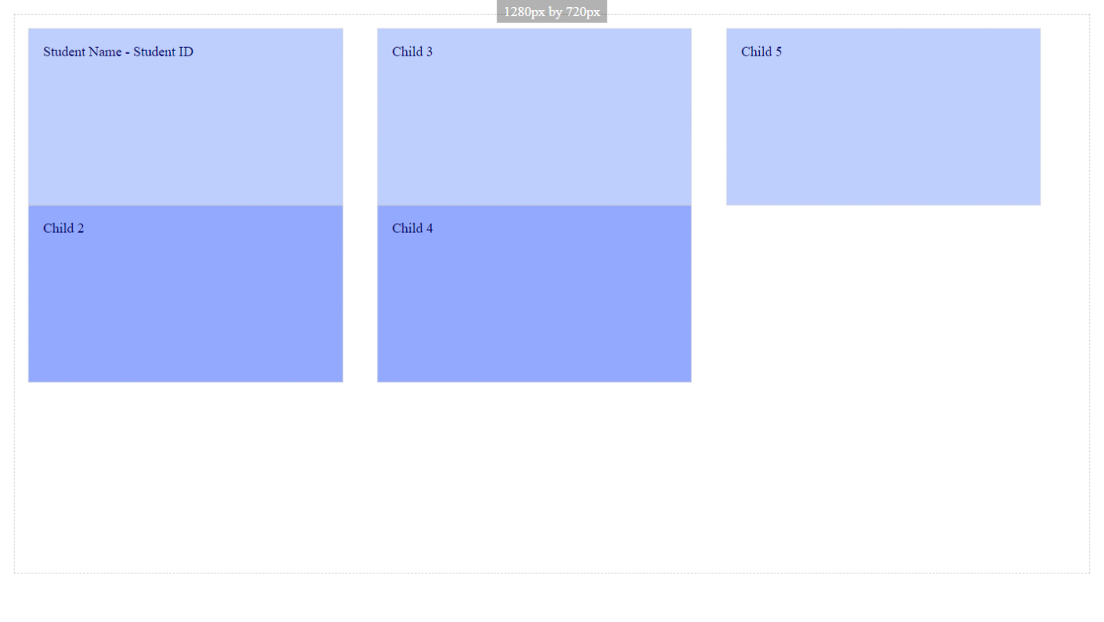

Paste a copy of your screenshot including your Student Name and Student ID (here)

Paste the style declaration you used to make your screenshot happen.

display:  
flex-flow:

Screenshot 10

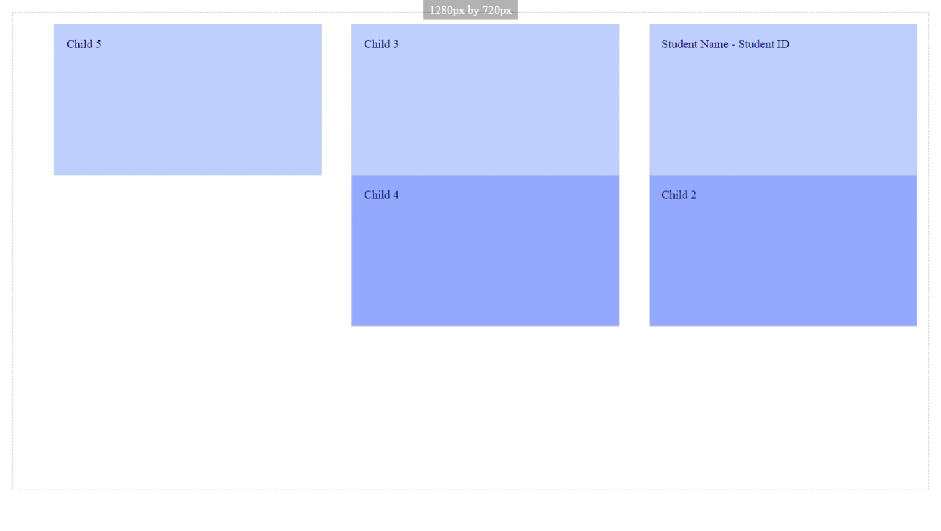

Paste a copy of your screenshot including your Student Name and Student ID (here)

Paste the style declaration you used to make your screenshot happen.

display:   
flex-flow:

Screenshot 11

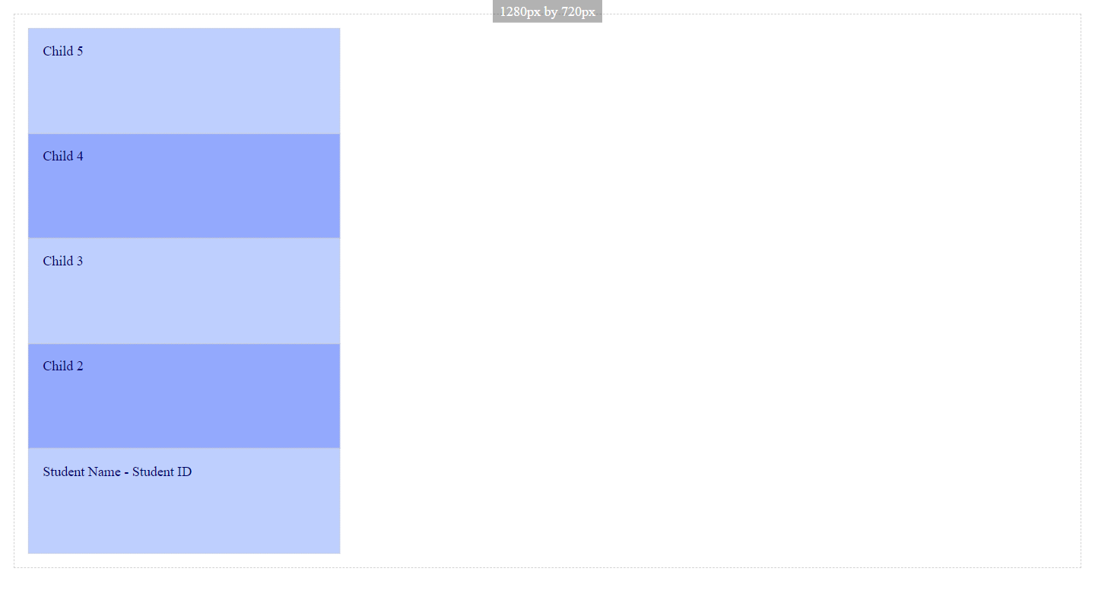

Paste a copy of your screenshot including your Student Name and Student ID (here)

Paste the style declaration you used to make your screenshot happen.

display:   
flex-flow:

Screenshot 12

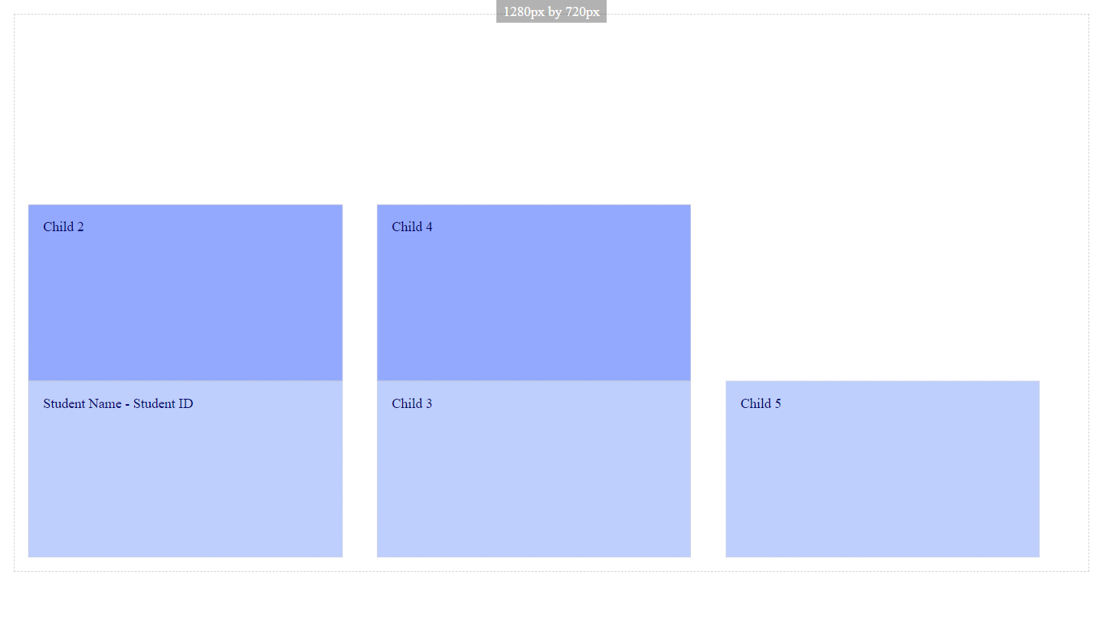

Paste a copy of your screenshot including your Student Name and Student ID (here)

Paste the style declaration you used to make your screenshot happen.

display:   
flex-flow: